COMP 7500/7506 – Lecture 21a: Advanced Topics in Page Tables
Exercise 1: What happens if two page numbers are hashed to the same location?
Answer: Build a chain.

Exercise 2: Answer the following two questions on the algorithm of hashed page tables.
- What is VPN?
- What is faulting_tag?
- What is ptr->mapping?
- When will function pagefault()be invoked?
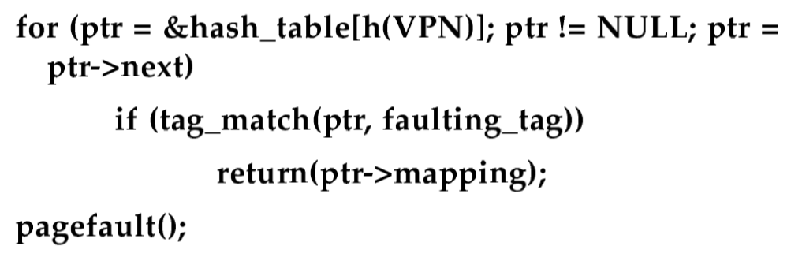
Answer: (1) VPN is page number (i.e., p), (2) the tag of the VPN, (3) returned frame number. (4) the VPN_tag hasn’t been found in the chain.

Exercise 3: Suppose the hash function is h(p) = p mod m, where p is the page number, m is the number of entries in a page table.
- What is the frame number of page 35?
- What is the frame number of page 12?
- What is the frame number of page 8?
- Which page number is listed in the wrong chain?
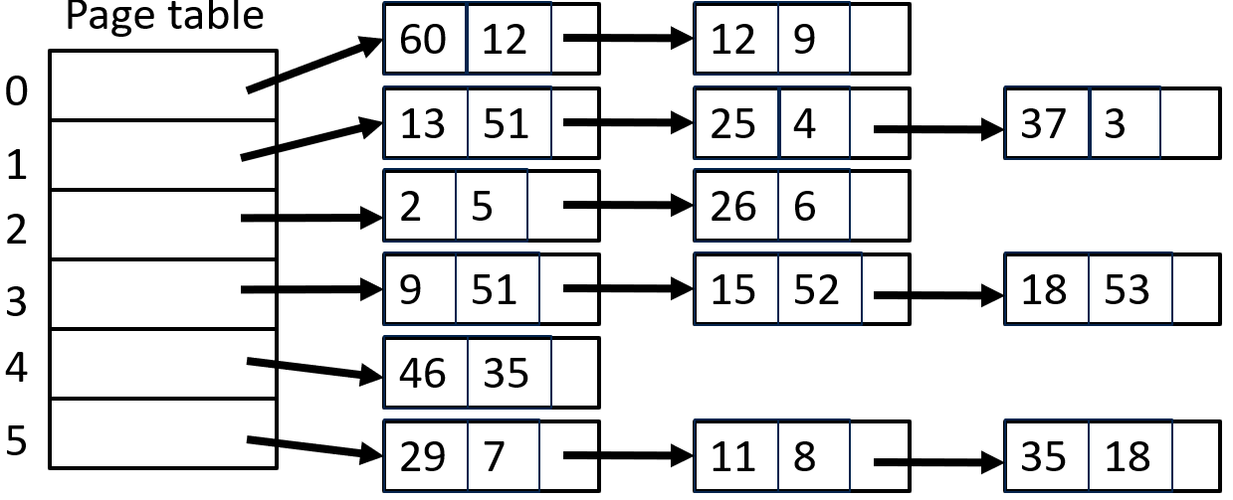
Answer: (1) 18, (2) 9, (3) page fault (4) (18,53).

COMP7500/7506 21b: Mock Exam 1
B. Exercise 1 (Plickers): What is the script command line used in project 1?
- To list file names
- To save a session of your terminal
- To compile your program
- To debuge your program

F. Exercise 2 (Plickers): Shared memory is far more common in operating systems than message passing.
- True B) False

T. Exercise 3 (Plickers): Message-passing systems are typically implemented using system calls.
- True B) False

D. Exercise 4 (Plickers): Which one of the following write statements is correct for UNIX pipes?
- write(my_pipe[1], message, strlen(message));
- write(my_pipe[0], message, strlen(message));
- write(my_pipe[0], message, strlen(message)+1);
- write(my_pipe[1], message, strlen(message)+1);
C. Exercise 5 (Plickers): Which one of the following close statements is correct?
- close(my_pipe[1], error);
- close(my_pipe[2]);
- close(my_pipe[0]);
- close(my_pipe[1], NULL);

B Exercise 6 (Plickers): How to calculate turnaround time?
A) Turnaround_time = Burst_time – Submission_time
B) Turnaround_time = Finish_time – Arrival_time
C) Turnaround_time = Wait_time – Submission_time
D) Turnaround_time = Wait_time – Burst_time

C Exercise 7 (Plickers): How to calculate wait time?
A) Wait_time = Burst_time – CPU_time
B) Wait_time = Finish_time – CPU_time
C) Wait_time = Turnaround_time – Burst_time
D) Wait_time = Finish_time – Burst_time

D Exercise 8 (Plickers): ____ is the number of processes that are completed per time unit.
A) CPU utilization
B) Response time
C) Turnaround time
D) Throughput

C Exercise 9 (Plickers): Which of the following scheduling algorithms must be nonpreemptive?
A) SJF,
B) RR
C) FCFS
D) priority algorithms

A. Exercise 10 (Plickers): What is the pthread_join()function?
A) To wait for its child thread to complete.
B) To wait for its parent thread to complete.
C) To wait for its brother thread to join.
D) To join the parent thread after its execution is done

Exercise 11: Let’s consider the following processes. (1) Show the scheduling order of the processes using a Gantt chart when we apply the preemptive EDF (a.k.a., Earliest Deadline First) scheduling algorithm. (2) What is the finish time of each process? (3) What is the turnaround time for each process? (4) What is the wait time for each process? (5) Which process miss its deadline?

Processes | Arrival Time | Deadline | Burst Time | Finish Time | Turnaround | Wait Time
P1 | 0 | 13 | 10 | 15 | 15 | 5
P2 | 4 | 11 | 5 | 9 | 5 | 0

Answer: (Meet) (Miss)
P1:A 4:6 P2:A 5:0 P2:F, P1:R 10:0 P1:F
-------------------------------------------------------------------------------------
1 4 9 15

Exercise 12: Let’s consider the following processes. (1) Show the scheduling order of the processes using a Gantt chart when we apply the non-preemptive priority scheduling algorithm. (2) What is the turnaround time for each process? (3) What is the wait time for each process? (1 – Highest Priority, 5 – Lowest Priority)
Processes | Arrival Time | Priority | Burst Time | Finish Time | Turnaround | Wait Time
P1 | 0 | 5 | 10 | 10 | 10 | 0
P2 | 4 | 3 | 5 | 38 | 34 | 29
P3 | 9 | 2 | 20 | 30 | 21 | 1
P4 | 18 | 1 | 3 | 33 | 15 | 12

Turn_Around = Finish_time – Arrival_time
Wait_Time = Turn_Around – Burst_Time

Exercise 13: Consider the following code segment:
pid t pid;
pid = fork();
if (pid == 0) /* child process */
fork();
fork();
How many unique processes are created?

Answer: 6
fork1 ------ parent p0 ------- fork3 p0
-------- p02

------ child p01 fork2------ child p01 ------ fork3 p01
------- p02

------ child’s child p011 ----- fork3 p011
----- p0111

